**Sprint 2 Plan**

**Product:** GoLift

**Team Name:** Team Squat Squad

**Release Name:** Release 2

**Sprint Completion Date:** July 18

Revision One

**Revision Date:** July 12

**Goal:** Make application that records workouts and food intake, make suggestions for workout and diet plans based on body type

**Tasks:**

*As someone who wants to have a healthier lifestyle, I want something that could help me get into the habit of being healthier*

Make an app that gives an example workout plan for user’s body type (1 point)

Make an app that gives example diet plans and a suggested intake for user’s body

type (1 point)

*As a person who focuses on lifting, I want to record how many reps and rests I had taken previously to see my improvements*

Make an app that can take in exercises done, reps and time (2 point)

*As someone watching their weight, I want to see the amount of calories I have been consuming*

Make an app that can take in food intake and records calories (2 point)

**Team Roles:**

Merrick Swaffar: (Product Manager)

Nishika Tripathi: (Scrum Master)

Siobhán O’Shea: (Scrum Master)

Jenna Wu: (Team - designer)

Peyton Fonck: (Team - developer)

**Initial Task Assignment:**

Merrick Swaffar: *As someone watching their weight, I want to see the amount of calories I have been consuming,* Make an app that can take in food intake and records calories (2 point)

Nishika Tripathi: *As someone who is watching his/her own diet, I want something that could suggest what to eat based on my needs,* Make an app that gives example diet plans and a suggested intake for user’s body type (1 point)

Siobhán O’Shea: *As someone who is just beginning to workout, I want something that could suggest what to work out based on my needs*,Make an app that gives an example workout plan for user’s body type (1 point)

Jenna Wu: *As a person who focuses on lifting, I want to record how many reps and rests I had taken previously to see my improvements,* Make an app that can record exercises done, reps and sets(2 point)

Peyton Fonck: *As a person who focuses on lifting, I want to record how many reps and rests I had taken previously to see my improvements,* Make an app that can record exercises done, reps and sets(2 point)

**Initial Burnup Chart:**

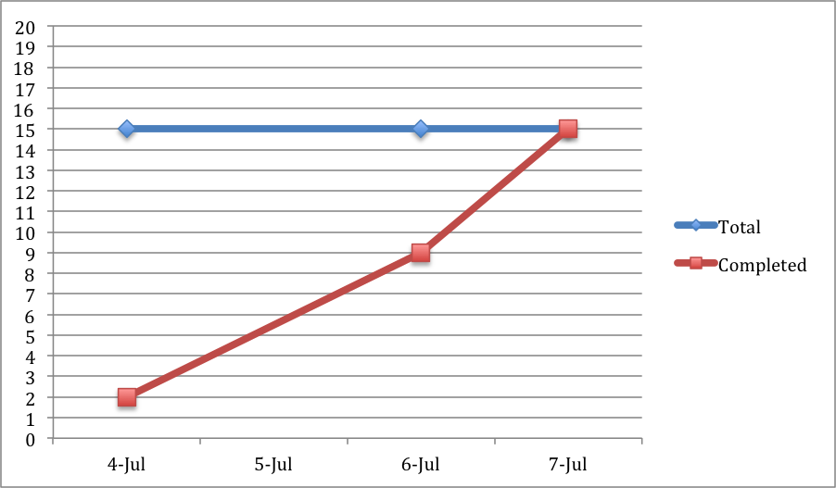

**Final Burnup Chart:**

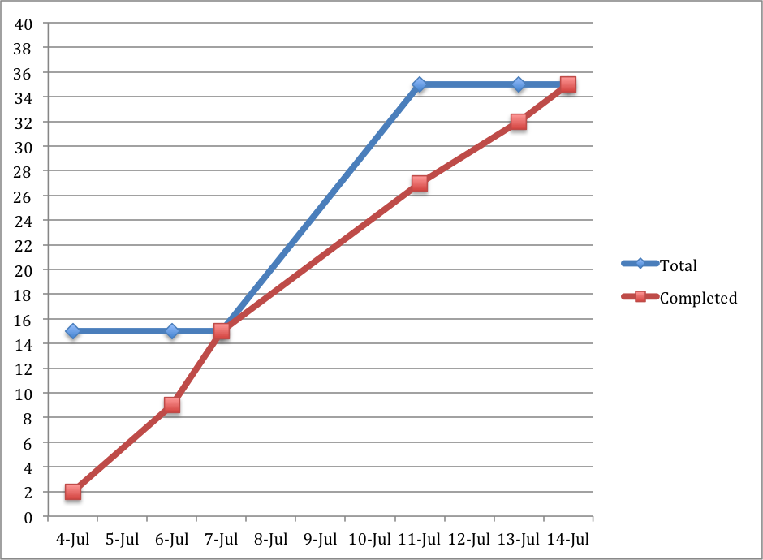

**Initial Scrum Board**

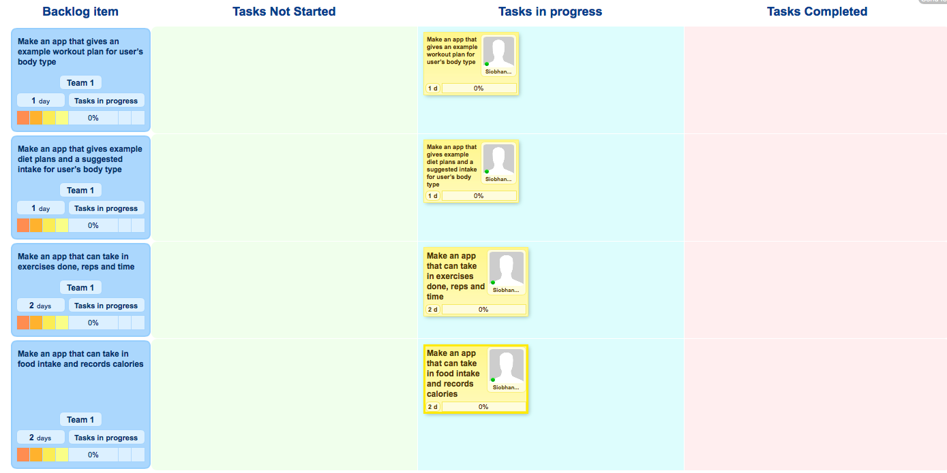

**Scrum Times**

Monday 4:30

Wednesday 4:30 (meeting with TA)

Thursday 12:30